­­ ­MINISTRY OF EDUCATION AND TRAINING

­

­

**FPT UNIVERSITY**

Capstone Project Document

**Interior Furniture Augmented Reality System for Online Shopping**

|  |  |
| --- | --- |
| **Group 3** | |
| **Group members** | Nguyễn Phước Anh Khoa – SE61742  Phan Hồng Đức - SE61835  Bùi Thanh Thiên- SE61813 |
| **Supervisor** | Kiều Trọng Khánh |
| **Ext. Supervisor** | N/A |
| **Capstone Project code** | ifAR |

-Ho Chi Minh City, ***08/01/2018*-**

**

**CAPSTONE PROJECT REGISTER**

Class: Duration time: From 08 /01/2018 To 25/04/2018

(*) Profession: <Software Engineer> Specialty: <ES> <IS>

x

(*) Kinds of person make registers: Lecturer Students

x

1. Register information for supervisor (if have)

|  |  |  |  |  |
| --- | --- | --- | --- | --- |
|  | **Full name** | **Phone** | **E-Mail** | **Title** |
| Supervisor 1 | Kiều Trọng Khánh |  | khanhkt@fpt.edu.vn | Mr. |

2. Register information for students (if have)

|  |  |  |  |  |  |
| --- | --- | --- | --- | --- | --- |
|  | **Full name** | **Student code** | **Phone** | **E-mail** | **Role in Group** |
| **Student 1** | Nguyễn Phước Anh Khoa | SE61742 | 0909987092 | khoanpase61742@fpt.edu.vn | Leader |
| **Student 2** | Phan Hồng Đức | SE61835 | 0966642912 | ducphsse61835@fpt.edu.vn | Member |
| **Student 3** | Bùi Thanh Thiên | SE61813 | 01863299920 | thienbtse61813@fpt.edu.vn | Member |

3. Register content of Capstone Project

(*) 3.1. Capstone Project name:

English: Interior Furniture Augmented Reality System for Online Shopping

Vietnamese: Nội thất AR trực tuyến

Abbreviation: ifAR

**- Context:**

+ It is difficult to choose the Interior Furniture at shop or expo that conforms users space in their house.

+ How to users make the generalized model about furniture to decorate their house?

+ The owners Furniture Shop always need big space to show their products. This is a big problem with them. Anyway, the users never satisfy with their choice. Especially, it takes place without their house.

**- Building the system provides following services:**

* It will help the user contemplate virtual real-world interior furniture anywhere in real world coexisted on the same view through a smartphone.
* The application provides user ability to scan, upload and contemplate interior furniture using smartphone, it also establishes an Interior Furniture Augmented Reality Marketplace for online shopping.
* Everyone can trade products online, contemplate products in real-world environment through smartphone.
* …

**- Simulator:**

* Make the online shopping with interior furniture.

(*) 3.2. Main proposal content (including result and product)

1. Theory and practice (document):

* Student should apply the software development process and the UML.
* Software artifacts include User Requirement, Software Requirement Specification, Architecture Design, Detail Design, System Implementation and Testing Document, Installation Guide, sources code, and deployable software packages.
* 3 tiers should be applied.
* Server side technique:
  + Database design, OOA, OOD, OOP, MVC, Java or .Net technology, …
* Client side technique:
  + HTML5, CSS, JavaScript, JQuery, Ajax, Android, Swift, ARKit...
* Communication technique:
  + Exchange information and transfer data in effective in networks, communicating protocol between mobile devices...
* Research
  + Android/iOS mobile development.
  + Augmented Reality.
  + 3D Model visualizer.
  + …

1. Program:

* Main functions:
  + Web Application for supporting staffs’ shop, administrator’s system.
  + Mobile Application for users (or/and Web Application with team members qualification).
  + …

1. Other products:

* All of management functions of the system must be implemented to support the operating system in best.
* Papers.

4. Other comment (propose all relative thing if have)

N/A

|  |  |
| --- | --- |
| **Supervisor (If have)**  *(Sign and full name)* | HCM city, date 14/12/2017  **On behalf of Registers**  *(Sign and full name)* |

Kiều Trọng Khánh

# Table of Contents

Contents

MINISTRY OF EDUCATION AND TRAINING - 1 -

Table of Contents - 5 -

List of Tables - 8 -

List of Figures - 8 -

Definitions, Acronyms, and Abbreviations - 9 -

A. Report No. 1 Introduction - 10 -

1. Project Information - 10 -

2. Introduction.. - 10 -

3. Current Situation - 10 -

4. Problem Definition - 12 -

5. Proposed Solution - 12 -

5.1 Feature functions - 12 -

5.2 Values and Challenges - 13 -

6. Functional Requirements - 14 -

B. Report No.2 Software Project Management Plan - 14 -

1. Problem Definition - 14 -

1.1 Name of this Capstone Project - 14 -

1.2 Problem Abstract - 14 -

1.3 Project Overview - 15 -

1.3.1 Current Situation - 15 -

1.3.2 The Proposed System - 15 -

1.3.2.1 Website - 16 -

1.3.2.2 Mobile Application - 16 -

1.3.2.3 Scheduler - 17 -

1.3.3 Boundaries of the System - 17 -

1.3.4 Future Plans - 17 -

1.3.5 Development Environment - 18 -

1.3.5.1 Hardware requirements - 18 -

1.3.5.2 Software requirements - 18 -

2. Project organization - 19 -

2.1 Software Process Model - 19 -

2.2 Roles and responsibilities - 19 -

3. Project Management Plan 20

3.1 Product Backlog 20

3.2 Sprint Backlog 20

3.3 All Meeting Minutes 20

C. Report No. 3 Software Requirement Specification 20

1. User Requirement Specification 20

1.1 Customer Requirement 21

1.2 Seller Requirement 21

1.3 Staff Requirement 21

1.4 Administrator Requirement 22

1.5 Authorized User Requirement 22

1.5 Scheduler Requirement 22

2. System Requirement Specification 23

2.1 External Interface Requirement 23

Please reference ifAR-Full.docx 23

2.2 System Overview Usecase 23

3. Conceptual Diagram 24

D. Report No. 4 Software Design Description 25

1. Design Overview 25

2. System Architectural Design 25

2.1 Web Server Architecture Description 25

2.1 iOS Application Architecture Description 27

2.2 Web Application Architecture Description 28

3. Component Diagram 28

4. Detailed Description 31

4.1 Class Diagram 31

4.2 Class Diagram Explanation 32

Please reference in ifAR-Full.docx 32

6. Database Design 33

6.1 Entity relationship diagram (ERD) 33

6.2 Data Dictionary 33

7. Database Relationship Diagram 34

7.1 Physical Diagram 34

7.2 Data Dictionary 34

7. Algorithms… 36

7.1 Augmented Reality – Plane Detection 36

7.1.1 Definition 36

7.1.2 Define Problem 36

7.1.3 Solution 36

7.1.4 Work flow 36

7.1.5 Reference 36

7.2 Augmented Reality – Placing Object 37

7.2.1 Definition 37

7.2.2 Define Problem 37

7.2.3 Solution 37

7.2.4 Work flow 37

7.2.5 References 37

7.2.6 Example 37

7.3 RealityCapture……………………………………………………………………..…........37

7.2.1 Definition 38

7.2.2 Define Problem 38

7.2.3 Solution 39

7.2.4 Work flow 39

7.2.5 References 39

7.2.7 Example 40

G. Appendix 40

Task sheet 41

# List of Tables

Table 1 Roles and Responsibilities 12

Table 2: Data dictionary 25

Table 3 Class dictionary 33

# List of Figures

Figure 1 Scrum framework 16

Figure 2: System Overview Usecase 21

Figure 3: Conceptual diagram 23

Figure 4 System overview architecture 24

Figure 5 Web server architecture 25

Figure 6 iOS MVC architecture 26

Figure 7 Web applicaiton architecture 27

Figure 8: Component Diagram 28

Figure 9 Component diagram 29

Figure 10 Class diagram 30

Figure 11 Entity relationship diagram 32

Figure 12: Extend Entity Relation Diagram 33

Figure 13 Augmented Reality - Plance detection work flow 34

Figure 14: Augmented Reality – Placing Object work flow 35

Figure 15: Augmented Reality – Placing Object example 36

Figure 16: Reality Capture work flow 37

Figure 17: Reality Capture example 38

Definitions, Acronyms, and Abbreviations

|  |  |
| --- | --- |
| **Name** | **Definition** |
| ifAR | Interior Furniture Augmented Reality System for Online Shopping |
| AR | Augmented Reality |
| RC | Reality Capture |
| Model | Model is a three-dimensional (3D) object which is used to represent a real-world object in our system. The model is created from seller’s series of pictures by system using Semi-auto processing*. |
| Product | Product is an interior furniture which is sold by retailer on our marketplace. |
| Semi-auto processing | Semi-auto processing: combines system automatic processes and designer manual processes. Model is generated automatically by system using RC, the model will include two files: a 3D image file (.obj format) and a texture image file (.jpg format). After that, designer is about to upgrade model’s quality using 3D editors: Autodesk 3DS MAX or Blender and change format of 3D image file from .obj to.scn to conform mobile application’s requirement using Apple Xcode manually. Goal model is included a 3D image file (.scn format) and a texture image file (.jpg format). |

A. Report No. 1 Introduction

## 1. Project Information

* Project name: **Interior Furniture Augmented Reality System for Online Shopping**
* Project Code: ifAR
* Product Type: **Web Application, Mobile Application.**
* Start Date: **January 8th, 2018**
* End Date: **April 28th, 2018**

## 2. Introduction

We would like to introduce the augmented reality project, which is an integral part of the mobile technology in the future. Nowadays, it is difficult to choose the Interior Furniture at shop or expo that conform customers’ space in their house. The customers also want to visualizate interior decoration before purchasing furniture. The furniture retailers always need large showroom to demonstrade their products. These are the big problems with both customers and retailers.

Build an application that allows users to superimpose virtual real-world objects into human vision in real-world environment via smartphones. It will help the users contemplate virtual real-world interior furniture anywhere in real world coexisted on the same view through a smartphone screen. Users have ability to scan, upload and contemplate interior furniture using smartphone. We also establish an Interior Furniture Augmented Reality Marketplace for Online Shopping, so that everyone can trade products online, contemplate products in real-world environment through smartphone.

We hope this application will affect positively on the quality of shopping life as well as. In future, we intend to extend the system to several other product types, not only interior furniture. The system will become online marketplace provides diversity products, converting pictures to 3D models semi-automatically.

## 3. Current Situation

In the last few years, Virtual Reality is becoming increasingly popular, as computer graphics have progressed to a point where the images are often indistinguishable from the real world. However, the computer-generated images presented in games, movies, and other media are detached from our physical surroundings. This is both a virtue—everything becomes possible—and a limitation.

The limitation comes from the main interest we have in our daily life, which is not directed toward some virtual worlds, but rather toward the real world surrounding us. Smartphones and other mobile devices provide access to a vast amount of information, anytime and anywhere. However, this information is generally disconnected from the real world. Consumers with an interest in retrieving online information from and about the real world, or linking up online information with the real world, must do so individually and indirectly, which, in turn, requires constant cognitive effort.

In many ways, enhancing mobile computing so that the association with the real world happens automatically seems an attractive proposition. A few examples readily illustrate this idea’s appeal. Location-based services can provide personal navigation based on the Global Positioning System (GPS), while barcode scanners can help identify books in a library or products in a supermarket. These approaches require explicit actions by the user. however, they are rather coarse grained. Barcodes are useful for identifying books, but not for naming mountain peaks during a hiking trip; likewise, they cannot help in identifying tiny parts of a watch being repaired, let alone anatomic structures during surgery.

Augmented reality holds the promise of creating direct, automation and actionable links between the physical world and electronic information. It provides a simple and immediate user interface to an electronically enhanced physical world. The immense potential of augmented reality as a paradigm-shifting user interface metaphor becomes apparent when we review the most recent few milestones in human–computer interaction: the emergence of the World Wide Web, the social web, and the mobile device revolution.

iOS is the world’s largest augmented reality platform. After Apple announces their iOS version 11.0 with batch new features and Augmented Reality (AR) is the most interesting feature that both users and developers want to experience. Games and apps now offer fantastically immersive and fluid experiences that go far beyond the screen. By taking advantage of the latest in AR technology, you can digitally redecorate your home, explore a city you’ve never visited, or even walk with dinosaurs. The possibilities are endless.

ARKit, Apple's augmented reality (AR) technology for building AR apps on iOS, delivers immersive, engaging experiences that seamlessly blend virtual objects with the real world. In AR apps, the device's camera presents a live, onscreen view of the physical world. Three-dimensional virtual objects are superimposed over this view, creating the illusion that they actually existed. The user can reorient their device to explore the objects from different angles and, if appropriate for the experience, interact with objects using gestures and movement.

The basic requirement for any AR experience—and the defining feature of ARKit—is the ability to create and track a correspondence between the real-world space the user inhabits and a virtual space where you can model visual content. When your app displays that content together with a live camera image, the user experiences augmented reality: the illusion that your virtual content is part of the real world.

(Reference: <https://developer.apple.com/ios/human-interface-guidelines/technologies/augmented-reality>,

<https://developer.apple.com/documentation/arkit/about_augmented_reality_and_arkit>)

ARCore is a platform for building augmented reality apps on Android. ARCore uses three key technologies to integrate virtual content with the real world as seen through your smartphone's camera:

* Motion tracking allows the phone to understand and track its position relative to the world.
* Environmental understanding allows the phone to detect the size and location of flat horizontal surfaces like the ground or a coffee table.
* Light estimation allows the phone to estimate the environment's current lighting conditions.

Fundamentally, ARCore is doing two things: tracking the position of the mobile device as it moves and building its own understanding of the real world.

ARCore's motion tracking technology uses the phone's camera to identify interesting points, called features, and tracks how those points move over time. With a combination of the movement of these points and readings from the phone's inertial sensors, ARCore determines both the position and orientation of the phone as it moves through space.

In addition to identifying key points, ARCore can detect flat surfaces, like a table or the floor, and can also estimate the average lighting in the area around it. These capabilities combine to enable ARCore to build its own understanding of the world around it.

ARCore's understanding of the real world lets you place objects, annotations, or other information in a way that integrates seamlessly with the real world. You can place a napping kitten on the corner of your coffee table, or annotate a painting with biographical information

about the artist. Motion tracking means that you can move around and view these objects from any angle, and even if you turn around and leave the room, when you come back, the kitten or annotation will be right where you left it.

(Reference: <https://developers.google.com/ar/discover>)

Until now, Google has not officially announced the technology Arcore so no third-party applications using arcore officially released.

We can see that a complete AR system requires at least three components: a tracking component, a registration component, and a visualization component. A fourth component—a spatial model (i.e., a database)—stores information about the real world and about the virtual world. The real-world model is required to serve as a reference for the tracking component, which must determine the user’s location in the real world. The virtual-world model consists of the content used for the augmentation. Both parts of the spatial model must be registered in the same coordinate system.

IKEA Place, the app lets you browse through a wide selection of IKEA products, all of which can be placed right in your home using the new augmented reality functionality built into iOS 11. Chairs, tables, sofas, storage solutions, and more are available. IKEA has added more than 2,000 items from its catalog. From there, you can browse through the furniture collection and see how items fit into a room. Items can be rotated and moved around in a room so you can get an idea of the size of a piece of furniture relative to what's already in the room. Multiple pieces of furniture can be added to the app at the same time, and there's an option to take a photograph that can be saved to the camera roll or shared.

## 4. Problem Definition

**Advantage of current system:**

* People can see, interact, feel the real material of interior furniture.
* Customer can directly evaluate the real material of the interior furniture.

**Below are disadvantages of current situation:**

* The furniture retailer always need large showroom to demonstrate their products.
* Renting space in expo is difficult and expensive.
* Difficult to choose the interior furniture at shop or expo that conforms users space in their house.
* Cost of imparting, preservation is expensive.

## 5. Proposed Solution

### 5.1 Feature functions

Our proposed solution is to build an e-commercial system for interior furniture integrating AR technology named "ifAR" which provides users ability to place virtual real-world furniture to the real world via smartphone. Sellers can also create 3D models from scan real-world furniture using their smartphone via ifAR mobile application then selling this furniture with 3D sample on our online marketplace.

ifAR includes a mobile application and web application with following features:

1. **ifAR mobile application:**

* **Customer:**
  + Place virtual real-world products to real world via smartphone’s camera.
  + Contemplate products via 3D models.
  + Go shopping online
  + Upgrade role to Seller.
* **Seller:**
* Place virtual real-world objects to real world via smartphone’s camera.
* Contemplate products via 3D models.
* Go shopping online
* Sell products.
* Create 3D model from real-world object overlap images.
* Manipulate products.
* Manipulate orders.

1. **ifAR web application:**

* **Staff:**
  + Manipulate seller’s sale requests.
  + Manipulate customer’s upgrade role request.
* **Admin:**
  + Including all features of Staff.
  + Manipulate Staff’s account.

### 5.2 Values and Challenges

**Values:**

* Applying AR & RC technology helps increase convience and save cost, time of trading interior furniture at home for both customers and sellers.
* Experience and trading products are convenient with online marketplace using AR technology.
* User can self create 3D virtual real-world furniture using smartphone.

**Challenges:**

* Device must be iPhone 6S or later with iOS version 11.3 or later.
* There’re some strong competitors such as: Amazon, IKEA…
* AR & RC technologies are existed some shortcomings:
* Surface detection of AR is low quality with low light level or on too flat surfaces.
* 3D models which are generated from RC have redundant textures, so that designer have to upgrade 3D models’ quality manually.

## 6. Functional Requirements

Functional requirements of the system are listed as below:

* **Customer’s components:**
  + Go shopping online
  + Simulate products through AR view
* **Seller’s components:**
  + Go shopping online
  + Simulate products through AR view
  + Request to sell products.
  + Manipulte orders.
  + Manipulate products.
* **Staff’s component:** 
  + Manipulate seller requests.
  + Manipulate customer’s role upgrading requests.
* **Desginer’s component:**
  + Include Staff’s components.
  + Edit product’s 3D model.
* **Administrator’s component:** 
  + Including all components of Designers & Staff’s components.
  + Manipulate Staff’s & Designer’s account.

B. Report No.2 Software Project Management Plan

## 1. Problem Definition

### 1.1 Name of this Capstone Project

* + **Offical name:** Interior Furniture Augmented Reality System for Online Shopping
  + **Abbreviation:** ifAR

### 1.2 Problem Abstract

Selecting and purchasing interior furniture are complex and inconvinient because imparting, demonstration, trying out furniture are high cost, time consuming. Therefore, we proposed a system for furniture online shopping enhancing experience with AR technology. This technology will bring the most authentic experiencing products for user through a smartphone.

Therefore, we need to develop a system provides online marketplace and uses AR technology to bring virtual real-world objects to real-world environment. There’re some strong competitors have implement this concept, but the cost is expensive and services aren’t provided in Vietnam.

Using AR technology to bring real experience for user means we are building a mobile application providing semi-automatic 3D furniture models creation from series of pictures and placing those ones to real world via smartphone camera. And we also provide online marketplace that user can trade products with each other, like Lazada, Tiki… This technology requires us about iOS development, computer vision, 3D design knowledge. We also provide a web application for administrator to Manipulate marketplace and 3D model creating process.

There are some company have provided this concept in the world such as Amazon, IKEA… but in Vietnam, there’s no company providing this concept yet (at the time this document was written).

After trying AR, 3D creation technology from variety companies, we decide to use AR technology of ARKit from Apple Swift and 3D creation technology of Reality Capture API from Autodesk. 3D creation process is a semi-auto processing, because creating 3D model from series of pictures is automatic by vision technology. However, the model will be contained redundant background and texture, so that we need to use 3D editor such as Autodesk Maya to filter and upgrade model’s quality manually.

### 1.3 Project Overview

1.3.1 Current Situation

By research other systems, we found some problem current situation below:

* Swift (Programming Language for iOS Application): Our team hasn’t experienced in this platform before.
* Augmented Reality: This is not a new technology but it has just become popular recently.
* ARKit: This is a new framework of Swift, it was released recently by Apple in WWDC2017.
* ARCore: This is a platform for building augmented reality apps on Android which similars to ARKit. ARCore uses three key technologies to integrate virtual content with the real world as seen through your phone’s camera.
* Vuforia Object Scanner: The Vuforia Object Scanner is an Android application that is used to scan a physical 3D object but its pricing is expensive.
* Autodesk Reality Capture API: The Reality Capture API provides a set of endpoints for the Photo to 3D capability. These endpoints allow you to manipulate the process of generating a 3D mesh from overlapping photos.
* 3D model semi-auto processing: It combines not only computer vision algorithm but also manually 3D editing by people.
* E-Commercial: difficulty to compete with other systems such as Lazada, Amazon, IKEA…

1.3.2 The Proposed System

Because Augmented Reality technology is going to become popular so we decided to research about it. There are many providers for AR solution, such as: Vuforia, Oculus, Apple, Google... with varied pricing. But there are two free, powerful AR platforms from two popular companies: ARKit of Apple and ARCore of Google. ARKit has been realease by apple at WWDC 2017. Besides, ARCore is preview version, it doesn’t advoid errors while implementing. ARKit is also used by large number of developer win world. So, we decided to choose ARKit instead of ARCore.

There are some APIs and SDKs that help to create 3D model, such as: Insight3d (open-source image based 3D modeling software), Unity Vuforia, Autodesk Forge Reality Capture API. However, Autodesk Forge Reality Capture API service is free for 1 years and is also cheaper than others. This API can generate 3D model simply and quickly with acceptable quality. Finally, we decided to use 3rd party API services from Autodesk Forge to resolve problem instead of using graphic designer software.

To create 3D model, we build a web application for create 3D model from 2D pictures. First, we use graphic designer software to create 3D models but this solution costs a lot of money and time, so we choose semi-automatic solution. Semi-auto processing is that we use 3rd API to convert 2D pictures to 3D model automatically with acceptable quality. After this step, designers edit 3D model to filter background and upgrade model’s quality manually using 3D Editor.

1.3.2.1 Website

Website is main portal for staff and administrator. Website application provide following features:

* + **Staff’s feature:** 
    - Manipulate seller requests.
    - Manipulate customer’s role upgrading requests.
  + **Desginer’s feature:**
    - Include Staff’s feature.
    - Edit product’s 3D model.
  + **Administrator’s feature:** 
    - Including all components of Designers & Staff’s feature.
    - Manipulate Staff’s & Designer’s account.
  + **Seller’s feature:**
    - Manipulate products.
    - Manipulate orders.

1.3.2.2 Mobile Application

Mobile application for seller and customer. Mobile application provides following features:

* **For customer:**
* Login
* Simulate products through AR view.
* Contemplate products via 3D view.
* Go shopping online.
* Upgrade role to Seller.
* **For seller:**
* Login
* Simulate products through AR view.
* Contemplate products via 3D view.
* Go shopping online.
* Request to create 3D model for product.
* Manipulate products.
* Manipulate orders.

1.3.2.3 Scheduler

We develop a scheduler in web server application with following features:

* Generate 3D model.
* Create notifications.

1.3.3 Boundaries of the System

This section supposes that the government laws accept our e-commercial system and seller’s information. Our system provides e-commercial system for users to trading interior furniture and support AR & RC technologies to improve experience and convience.

The language of this system is English.

The complete product includes:

* Website application for seller, staff and administrator.
* Mobile application for guest, customer and seller.
* Web server.

**Our system supports:**

* User can simulate products through AR view on smartphone without any addition divice.
* User also contemplates product via 3D view.
* Customer can go shopping online.
* Seller can request to sell products with 3D model which will be generated from seller’s pictures.
* Seller is able to manipulate his/her products & orders.
* Staff and Degisner can manipulate seller information and sale requests.
* System supports create 3D model from seller’s pictures.
* Support language is English.
* Currency is US Dollar ($).

**Our system hasn’t supportted features below yet:**

* Manipulate staff
* Manipulate inventory.
* Manipulate product’s quality.
* Trade models between sellers.
* Use 3D model which provided by seller to represent product in AR view.
* Recommended system for searching product is not available.
* Multi-languages and currencies are not support yet.

(This is simulated system for e-commerce system)

1.3.4 Future Plans

The current system only support for iOS and staff has to approve seller’s pictures manually, so we recommend some features for future plans:

* Mobile application will be available on Android.
* Seller can use his/her own 3D model for product or trading model with other sellers.
* Apply color selection on 3D model.
* Support manipulate inventory & product’s quality.
* Apply multi-languages and currencies.
* Support rate quality for product.

1.3.5 Development Environment

1.3.5.1 Hardware requirements

**For server**

|  |  |  |
| --- | --- | --- |
| **Hardware** | **Minimum Requirements** | **Recommended** |
| Internet Connection | Cable, Wi-Fi (7 Mbps) | Cable, Wi-Fi (20 Mbps) |
| Computer Processor | Intel® Core ® i7 2.4GHz | Intel® Core ® i7 2.4GHz |
| Computer Memory | 8GB RAM | 12GB or more |

Table 2: Hardware Requirement for Server

**For smartphone**

|  |  |  |
| --- | --- | --- |
| **Hardware** | **Minimum Requirements** | **Recommended** |
| Internet Connection | Wi-Fi (7 Mbps) | Wi-Fi (14 Mbps) |
| Operating System | iOS 11.3 | iOS 11.3 or later |
| Device Version | iPhone 6S | iPhone 7 Plus or later |

Table 3: Hardware Requirement for Client

1.3.5.2 Software requirements

|  |  |  |
| --- | --- | --- |
| **Software** | **Name / Version** | **Description** |
| Environment | Java EE 7  Swift 4 | Specification for developing web application  Specification for developing mobile application |
| Modeling tool | Star UML | Used to design diagram |
| IDE | Eclipse Neon.3 Release (4.6.3)  Xcode 9.3  MySQL Workbench 6.3.9 | Programming tools |
| DBMS | MySQL 5.6.30 | Used to create & manage the database for system |
| Source control | GitKraken Pro (3.5.1) | Used for source control |
| Web browser | Chrome 42 or later | Testing browser |
| Mobile OS | iOS 11.3 or later | Testing mobile application |

Table 4: Software requirements

## 2. Project organization

### 2.1 Software Process Model

This project is developed under Scrum model. Below are the reasons why we choose this model:

* We have researched about Augmented Reality before. The risk of changing algorithm is high because proving accuracy of those algorithms is complicated. We need to use “try and test” method.
* The project contains a complicated system and the AR concept is very new for us, so we we need to try many design before the system run stability.

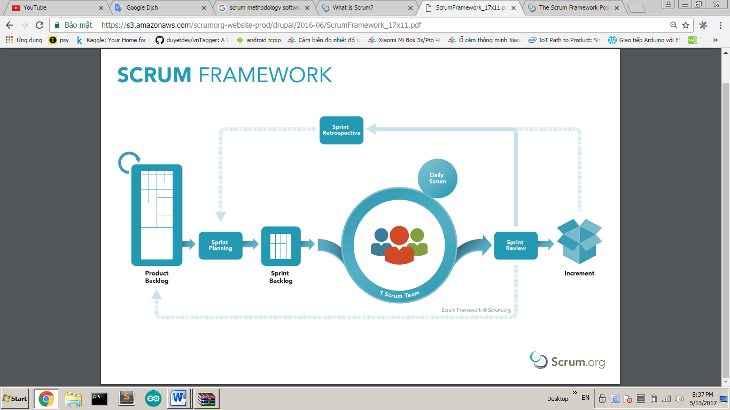

Figure 1 Scrum framework

Reference: <https://www.scrum.org/resources/what-is-scrum>

### 2.2 Roles and responsibilities

|  |  |  |  |
| --- | --- | --- | --- |
| **No** | **Full name** | **Role in Group** | **Responsibilities** |
| 1 | Kiều Trọng Khánh | Product Owner | * Specify scope and requirements * Control the development process * Give out technique and business analysis support * Product backlog management |
| 2 | Nguyễn Phước Anh Khoa | Scrum master | * Managing process * Designing database * Clarifying requirements * Prepare documents * Coding * Testing * Quality management * Risk management * Create test plan * Arrange meeting |
| 3 | Phan Hồng Đức | Scrum team member | * Designing database * Create test plan * Clarifying requirements * Prepare documents * Coding * Testing * GUI design |
| 4 | Bùi Thanh Thiên | Scrum team member | * Designing database * Create test plan * Clarifying requirements * Prepare documents * Coding * Testing * GUI design |

Table 5: Roles and Responsibilities Details

## 3. Project Management Plan

### 3.1 Product Backlog

Please reference in ifAR-Full.docx

### 3.2 Sprint Backlog

### 3.3 All Meeting Minutes

All meeting minutes are saved at: <https://drive.google.com/drive/folders/1j4HTd58bhlBSbwdLoHMNTx-TY1EbrGu0?usp=sharing>

# C. Report No. 3 Software Requirement Specification

## 1. User Requirement Specification

Our system is designed to solve the problem of helping customers choose interior furniture that they don’t know the interior furniture items fit the size of their home or not. Customers can also contemplate products with 360 degree view through their smartphone. We also provide online marketplace that sellers can demonstrate, sell their products with lower costs than the traditional way. This software consists of four user roles that are Customer, Seller, Staff, Admin with Staff and Admin are our employees.

1.1 Customer Requirement

Customer is a person who doesn’t have access to the system. Customer can only use shopping function and chooses and places virtual real-world objects to real world on mobile. For payment, customer must login. These are some functions customer can use*:*

* Register
* Login
* Upgrade role to Seller
* Search product
* Add product to cart
* Get cart
* Execute payment
* Place virtual real-world objects to real world on mobile.
* Contemplate products via 3D models.

1.2 Seller Requirement

Seller is a person who doesn’t have access to the system. Seller is a role that upgrade from Customer to have more features. There are some functions, Seller can use besiding Customer’s function:

* Login
* Search product
* Add product to cart
* Get cart
* Execute payment
* Place virtual real-world objects to real world on mobile.
* Contemplate products via 3D models.
* Request to sell product
* Manipulate products

1.3 Staff Requirement

Staff is an employee in the system who has responsible for technical work such as approving requests from customer to upgrade role to seller, 3D model generating, editing 3D model result. Staff can do the following functions:

* Approve Customer’s information to upgrade role from Customer to Seller
* Manipulate customer and seller
* Approve Seller’s product
* Update model’s quality
* Manipulate product

1.4 Administrator Requirement

Administrator is a person who has all functions of Staff and can also manipulate staffs’ account.

1.5 Authorized User Requirement

Authorized user is a person who already logined success into system. Authorized user can do the following task:

* Logout
* Edit profile.

1.5 Scheduler Requirement

Scheduler can run some functions in backend. Scheduler user can do the following task:

* Generate 3D model
* Send notifications

## ****2. System Requirement Specification****

### 2.1 External Interface Requirement

### Please reference ifAR-Full.docx

2.2 System Overview Usecase

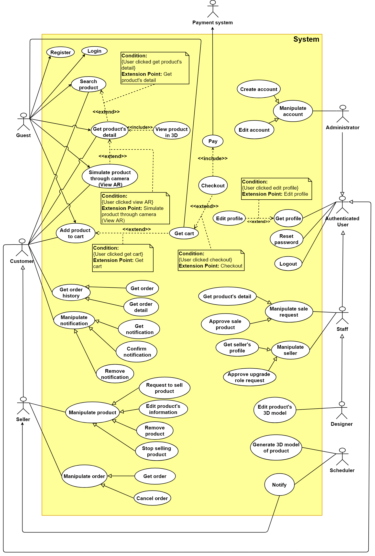

Figure 2: System Overview Usecase

## 3. Conceptual Diagram

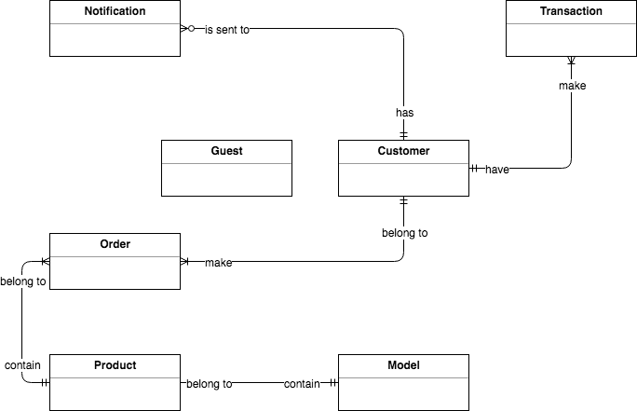

Figure 3: Conceptual diagram

**Data Dictionary**

|  |  |
| --- | --- |
| **Entity Data dictionary:** describe all content of all entities | |
| **Entity Name** | **Description** |
| Notification | Contain the notification information. |
| Transaction | Contain the transaction information. |
| User | Abstract entity describes a user in system |
| Order | Contain customer’s order information |
| Product | Contain the product information provided by seller |
| Model | Contain the model information associated with its product |

Table 2: Data dictionary

# D. Report No. 4 Software Design Description

1. Design Overview

This document describes the technical and user interface design of **ifAR System**. It includes the architectural design, the detailed design of common functions and business functions and the design of database model.

The architectural design describes the overall architecture of the system and the architecture of each main component and subsystem*.*

The detailed design describes static and dynamic structure for each component and functions. It includes class diagrams, class explanations and sequence diagrams for each use cases*.*

The database design describes the relationships between entities and details of each entity*.*

Document overview:

* + Section 2: gives an overall description of the system architecture design.
  + Section 3: gives component diagrams that describe the connection and integration of the system.
  + Section 4: gives the detail design description which includes class diagram, class explanation, and sequence diagram to details the application functions.
  + Section 5: describe screens design.
  + Section 6: describe a fully attributed ERD.
  + Section 7: describe algorithms**.**

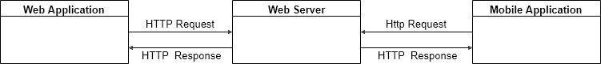2. System Architectural Design

Figure 4 System overview architecture

### 2.1 Web Server Architecture Description

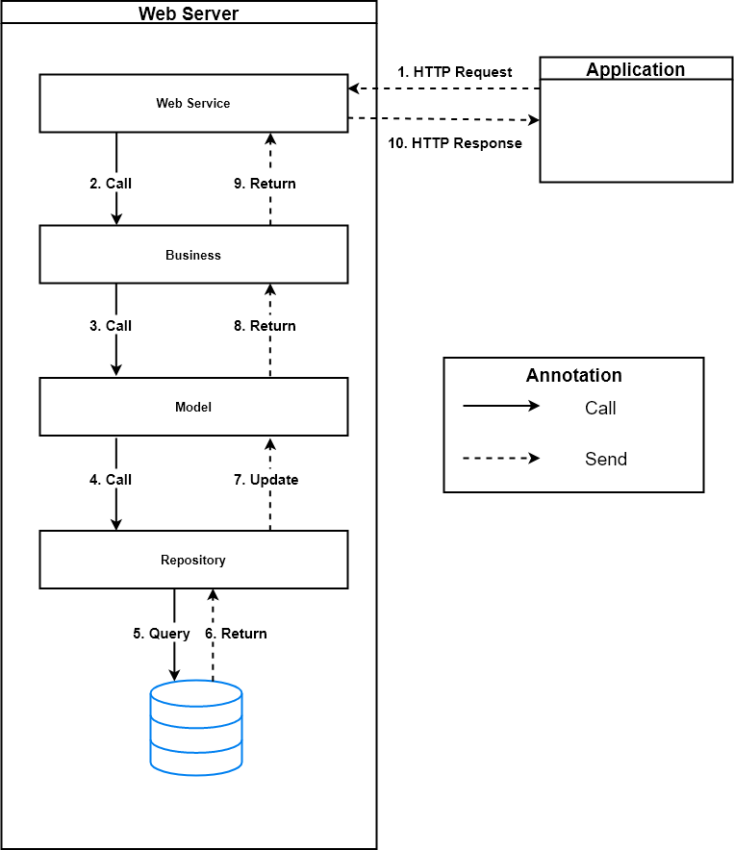

Figure 5 Web server architecture

In Web Application, the system is developed under Spring MVC architecture style. We choose this architecture for Web application because of following advantages:

* Web application contains a Web service (public API for mobile app), with MVC architecture, we can separate business code with Controller and View, so we can use the business code in web service without repeat the code.
* Spring comes with some of the existing technologies like Hibernate framework, security framework and J2EE etc. Hence, we don’t need to integrate explicitly those technologies.
* Spring can eliminate the creation of the singleton and factory classes and well defined interface to business layer
* By separating concerns into 3 distinct pieces, we can perform unit testing easily. Our Presentation layer can be tested free of the Model or Controller, and vice-a-versa
* Spring supports all aspects of application development, Business aspects, persistence aspects, etc., so we can develop a complete application.

This project follows MVC architecture with following components:

* **Spring Controller**: is the parts of the application that acts like event handler to handles user interaction. Typically, controller reads data from a request and calls appropriate Business’s method then selects view to return to user.
* **View**: The view renders the contents of a model. It gets data from the model and specifies how that data should be presented. It updates data presentation when the model changes. A view also forwards user input to a controller. Depending on the task being performed by the user the model can be looked at from different perspectives.
* **Model**: Represents the business data and any business logic that govern access to and modification of the data. The model notifies views when it changes and lets the view query the model about its state. It also lets the controller access application functionality encapsulated by the model. Typically, when a change in the model is to be reflected from user, it should be reflected in all the model’s views.

### iOS Application Architecture Description

### 

Figure 6 iOS MVC architecture

(Reference: <https://medium.com/ios-os-x-development/ios-architecture-patterns-ecba4c38de52>)

In iOS application, the system is developed under MVC architecture style. We choose this architecture for iOS because of following advantages**:**

* **Distribution** — the View and the Model in fact separated, but the View and the Controller are tightly coupled.
* **Testability** — due to the bad distribution you’ll probably only test your Model.
* **Ease of use** — the least amount of code among other patterns. In addition, everyone is familiar with it, thus, it’s easily maintained even by the unexperienced developers.

### Web Application Architecture Description

### C:\Users\Thuans\Downloads\Untitled Diagram (5).png

Figure 7 Web applicaiton architecture

In web application, the system is developed under MVC architecture for single-page application style. We choose this architecture for web application because of following advantages:

* With thetwo-way data binding, the user interface changes are immediately reflected in the underlying data model. Restrict web page refresh each time request to server, web application becomes friendly.

Web application follows MVC architecture with following components:

* **Controller**: is the parts of the application that acts like event handler to handles user interaction.
* **View**: The view renders the contents of a model. It gets data from the model and specifies how that data should be presented. In web application, view often descripts html pages.
  + - **Model**: Represents the business data and any business logic that govern access to and modification of the data. The model notifies views when it changes and lets the view query the model about its state.
    - **Two ways binding mechanism**: Two ways data-binding is an automatic way of updating the view whenever the model changes, as well as updating the model whenever the view changes.

## ****3.**** Component Diagram

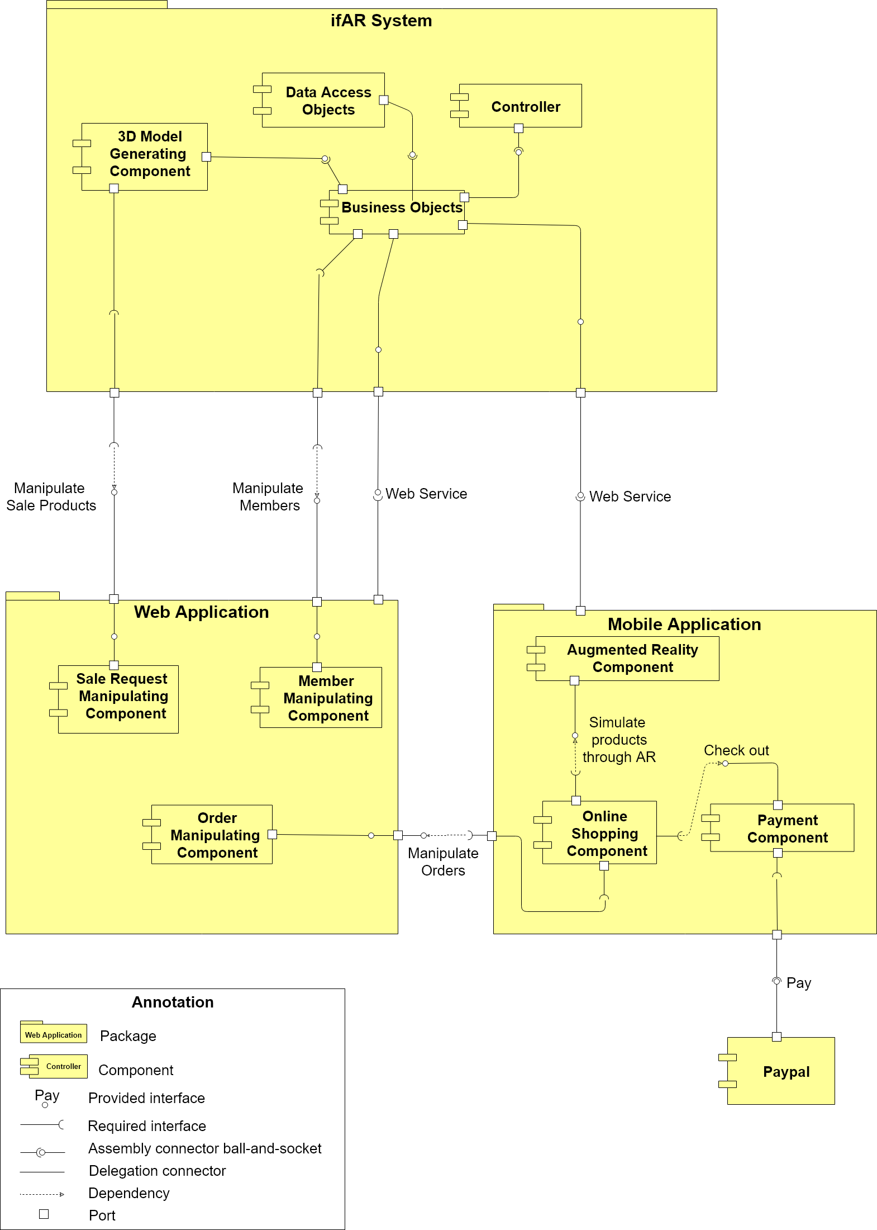

Figure 8: Component Diagram

**Data dictionary:** Please reference in ifAR-Full.docx

## 4. Detailed Description

### 4.1 Class Diagram

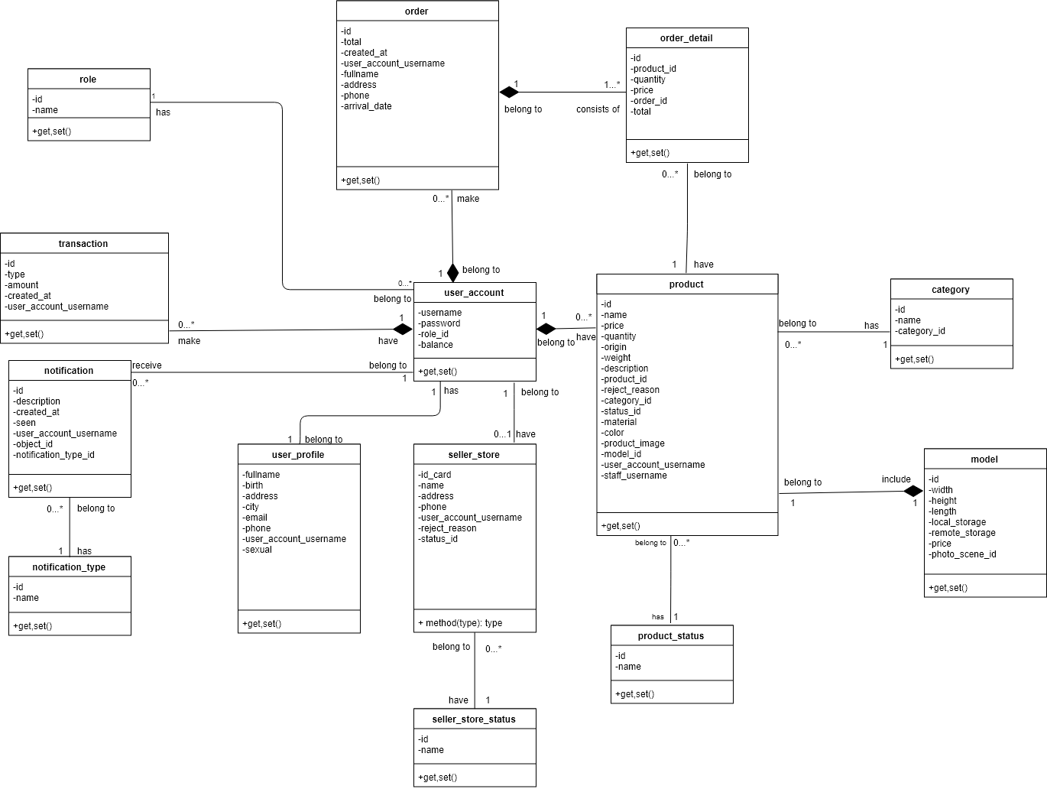

Figure 10 Class diagram

|  |  |  |
| --- | --- | --- |
| **Class Name** | **Mapping column with Conceptual diagram** | **Description** |
| role | N/A | Not exist in conceptual diagram. It’s used to contain role information. |
| order | order | Contain customer’s order information. |
| order detail | N/A | Not exist in conceptual diagram. It’s used to contain order detail information. |
| transaction | transaction | Contain customer’s transaction information. |
| notification | notification | Contain notification information. |
| notification_type | N/A | Not exist in conceptual diagram. It’s used to contain notification type of notification. |
| user_account | user | Contain customer’s information. |
| user_profile | N/A | Not exist in conceptual diagram. It’s used to contain user profile information of user account. |
| seller_store | store | Contain seller’s store information. |
| seller_store_status | N/A | Not exist in conceptual diagram. It’s used to contain store status of seller store. |
| product | product | Contain product’s information. |
| product_status | product_status | Not exist in conceptual diagram. It’s used to contain product status of product. |
| category | N/A | Not exist in conceptual diagram. It’s used to contain category information of product. |
| model | model | Contain model’s information of product. |

Table 3 Class dictionary

### 4.2 Class Diagram Explanation

##### Please reference in ifAR-Full.docx

## 6. Database Design

### 6.1 Entity relationship diagram (ERD)

Figure 11 Entity relationship diagram

### 6.2 Data Dictionary

Please reference in ifAR-full.docx

## 7. Database Relationship Diagram

### 7.1 Physical Diagram

Figure 12: Extend Entity Relation Diagram

7.2 Data Dictionary

Please reference in ifAR-Full.docx

## 7. Algorithms

### 7.1 Augmented Reality – Plane Detection

##### 7.1.1 Definition

The plane detection algorithm of Augmented Reality automatically detects multiple planes based on the proposed constrained sampling strategy.

##### 7.1.2 Define Problem

The whole concept behind Augmented Reality is blending together the reality around us with virtual objects that exist only within our App. In order to be able to do that successfully, we need to be aware of the geometry of our surroundings.

In other words, we need to be able to identify the ceilings, walls, tables and other physical objects.

Each plane has many specific point on it which will help us to build an algorithm to recognize plane. But we get some problems:

* Need a lot of time for building a good identification algorithm.
* Solution need to be stable to ensure reliability of system.

##### 7.1.3 Solution

Then we decide to use ARKit to detect plane with following concept:

* **Plane detection:** Plane detection is the ability to determine surfaces or planes in the physical environment. This is thing like the ground floor or may be a table.
* **Hit-testing:** Getting an intersection with the real-world topology so that you can place your virtual object in the physical world.
* **Light estimation:** Use to render or correctly light your virtual geometry to match that of the physical world.

##### 7.1.4 Work flow

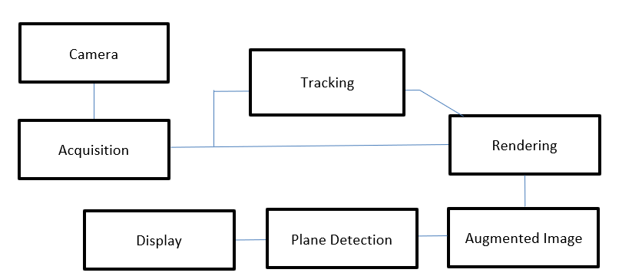

Figure 13 Augmented Reality - Plance detection work flow

##### 7.2.5 References

Augmented Reality with ARKit: Detecting Planes:

<https://developer.apple.com/documentation/arkit/arframe/2875718-hittest>

### 7.2 Augmented Reality – Placing Object

##### 7.2.1 Definition

The placing object algorithm of Augmented Reality used for place object on existing surface in Augmented Reality.It determines the surface existing in Augmented Reality and place the object on that surface.

##### 7.2.2 Define Problem

After the system detected surface, we need an algorithm to help the system place object on existing surface in Augmented Reality.

To implement the algorithm, we use Hit-testing concept of ARKit to solve the algorithm of placing object on existing surface in Augmented Reality.

##### 7.2.3 Solution

To solve this problem, we should use Hit-testing concept of ARKit. Hit testing searches for real-world objects or surfaces detected through the AR session's processing of the camera image. A 2D point in the image coordinates can refer to any point along a 3D line that starts at the device camera and extends in a direction determined by the device orientation and camera projection. This method searches along that line, returning all objects that intersect it in order of distance from the camera. After surface detected, hit-testing will support to place the object on that surface.

##### 7.2.4 Work flow

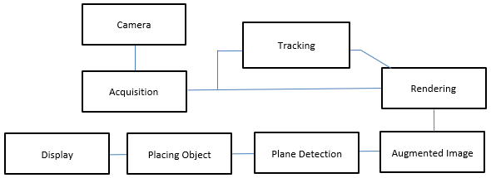

Figure 14: Augmented Reality – Placing Object work flow

##### 7.2.5 References

Apple Developer Documentation: Hit-test method:

<https://developer.apple.com/documentation/arkit/arframe/2875718-hittest>

##### 7.2.6 Example

Place 3D model of Ancient vase on table:

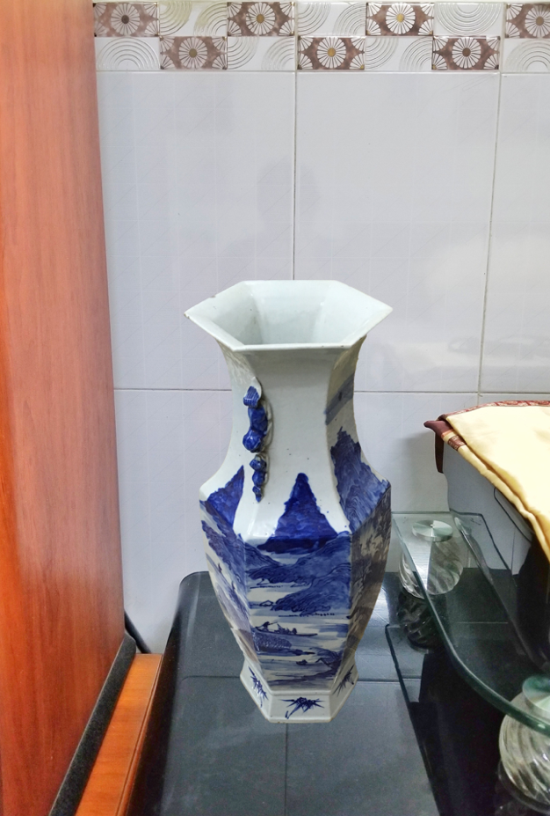

Figure 15: Augmented Reality – Placing Object example

### 7.3 Reality Capture

#### 7.3.1 Definition

Reality capture is the process of scanning an object, building, or site and producing a digital model representation—allows today’s builders to capture site data quickly and more accurately than ever before and connect it directly to the digital design process. The result is a comprehensive 3D model based on millions of data points mapping the entire site, whether it’s a building renovation or an infrastructure project, often including a look at the systems that function below the surface. Reality Capture uses object recognition - a process for identifying a specific object in a digital image or video. Object recognition algorithms rely on matching, learning, or pattern recognition algorithms using appearance-based or feature-based techniques, to detect the object inside series of input images.

Thanks to Reality Capture, even user who doesn’t have experience in design is able to create 3D model, it also saves huge time and effort comparing to traditional way. The objects have small or medium size and average complexity are created in short time with almost exactly exteriority. Even smartphone’s camera can be used for Reality Capture.

#### 7.3.2 Define Problem

In normally, interior furniture is usually represented by list of images or in advance with 360o videos which can’t satisfy customer. Customers feel hard to determine the actual size and shape of furniture when they put them to their house.

To solve this problem, some online store applied 3D model to their website to give customer a better view. However, creating 3D model costs much time and money which makes product’s price more expensive.

#### 7.3.3 Solution

To solve this problem, we use Reality Capture to generate 3D model with Semi-auto processing that saves a lot of time and money. User only need to provide series of overlap pictures capturing the product with all aspects.

#### 7.3.4 Work flow

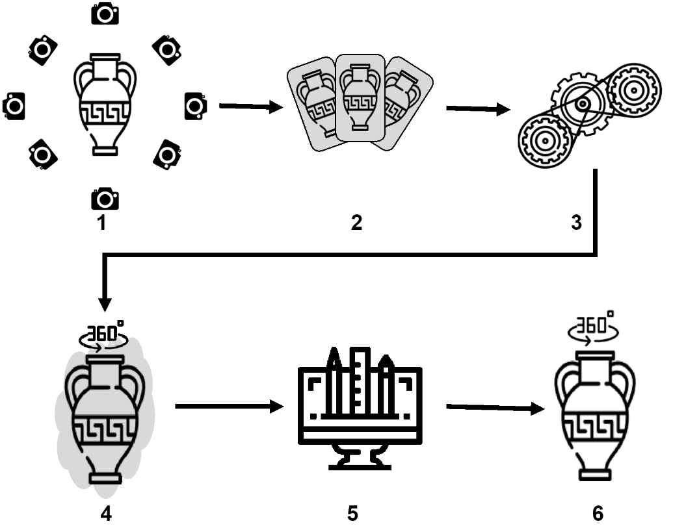

Figure 16: Reality Capture work flow

1. Capture series of overlap pictures of object with same distance at least 30 images.
2. Send these pictures to system with information about object: width, length, heigh and color.
3. Scheduler is going to generate 3D model from pictures provided by user.
4. Result model contains redundant textures (raw model) and need to upgrade quality.
5. Designer has responsibility to edit raw model, the raw model is removed unnecessary texture and fixed size, detail.
6. After being edited, the model is ready to represent the object. This model can be used in both AR view or 3D view.

#### 7.3.5 References

Kylee Swenson (2017). What is Reality Capture?: Redshift by Autodesk. <https://www.autodesk.com/redshift/what-is-reality-capture/>

#### 7.3.6 Example

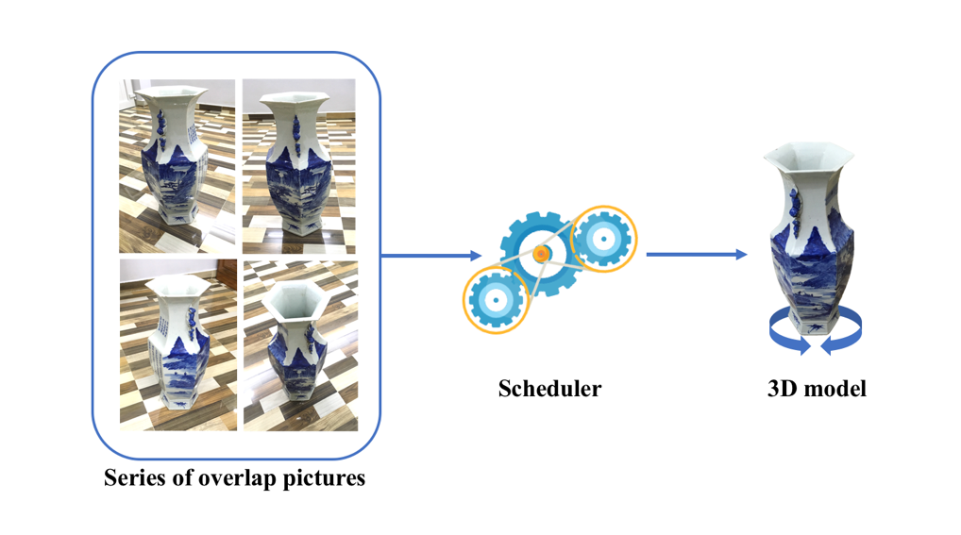The example below is our Ancient Ceramic Vase:

Figure 17: Reality Capture example

# G. Appendix

The reference components of the reference material refer to the way of writing at: <http://www.khoahocviet.info/meresci/vi/meresci03d4.html>

# Task sheet

|  |  |  |  |  |  |  |  |
| --- | --- | --- | --- | --- | --- | --- | --- |
| **No.** | **Product Deliverables** | **Task** | **KhoaNPA** | **DucPH** | **ThienBT** | **Unit** | **Size** |
| 1 | Report1 - Introduction | Project Information | **O** |  |  |  | 1 |
| Introduction | **O** |  |  |  | 1 |
| Current Situation | **O** | **O** | **O** |  | 1 |
| Problem Definition | **O** | **O** | **O** |  | 1 |
| Proposed Solution | **O** | **O** | **O** |  | 1 |
| Functional Requirement | **O** | **O** | **O** |  | 1 |
| Role and Responsibility | **O** |  |  |  | 1 |
| 2 | Report2- Software Project Management Plan | Problem Definition | **O** | **O** | **O** |  | 1 |
| Project organization | **O** |  |  |  | 1 |
| Project management plan | **O** |  |  |  | 1 |
| Coding Convention | **O** |  |  |  | 1 |
| 3 | Report 3- Software Requirement Specification | User Requirement Specification | **O** |  |  |  | 1 |
| **System Requirement Specification** | **O** |  |  |  |  |
| External Interface Requirements | **O** |  |  |  | 1 |
| System Overview Usecase | **O** | **O** | **O** |  | 5 |
| **List of Usecase** |  |  |  |  |  |
| Administrator Usecase |  |  | **O** |  | 1 |
| Authenticated User Usecase | **O** |  |  |  | 1 |
| Guest Usecase |  |  | **O** |  | 1 |
| Customer Usecase |  | **O** |  |  | 5 |
| Seller Usecase |  | **O** |  |  | 5 |
| Staff Usecase |  |  | **O** |  | 5 |
| Designer Usecase | **O** |  |  |  | 1 |
| Scheduler Usecase | **O** |  |  |  | 1 |
| Payment System Usecase | **O** |  |  |  | 1 |
| Software System Attribute |  | **O** | **O** |  | 1 |
| Conceptual Diagram |  | **O** |  |  | 3 |
| 4 | Report 4- Software Design Description | Design Overview | **O** |  |  |  | 2 |
| System Architectural Design | **O** |  |  |  | 2 |
| Component Diagram | **O** |  |  |  | 5 |
| **Detailed Description** |  |  |  |  |  |
| Class Diagram |  | **O** |  |  | 5 |
| Interaction Diagram |  |  | **O** |  | 5 |
| Interface | **O** |  | **O** |  | 5 |
| Database Design | **O** | **O** | **O** |  | 5 |
| **Algorithms** |  |  |  |  |  |
| Reality Capture | **O** |  | **O** |  | 5 |
| Augmented Reality | **O** | **O** |  |  | 5 |
| 5 | Report 5 - Software Implementation and Test Document | Introduction | **O** |  |  |  | 1 |
| Database Relationship Diagram | **O** |  | **O** |  | 5 |
| **Perform Measure** |  |  |  |  |  |
| Reality Capture Measure |  | **O** | **O** |  | 5 |
| Augmented Reality Measure | **O** | **O** |  |  | 5 |
| Test plan | **O** |  |  |  | 2 |
| **System Testing Test case** |  |  |  |  |  |
| Communication Diagram | **O** |  |  |  | 2 |
| **Mobile application test case** |  |  |  |  |  |
| Simulate products via AR view |  | **O** |  |  | 5 |
| Execute payment via Paypal |  | **O** |  |  | 4 |
| **Web application test case** |  |  |  |  |  |
| Manipulate sale product |  |  | **O** |  | 5 |
| Generate 3D model from iamges |  |  | **O** |  | 5 |
| 6 | Report 6 - Software User's Manual | Installation Guide | **O** |  |  |  | 1 |
| **User’s Guide** |  |  |  |  |  |
| Web application | **O** |  |  |  | 1 |
| Mobile application | **O** |  |  |  | 1 |